Summary of current programs, initiatives and services for people with macular disease

Australian Government Department of Health

Contents
1. Introduction 3
2. Macular disease – the Australian context 4
2.1 Macular disease in Australia 4
2.2 The impact of macular disease 5
3. Macular disease and eye health services in Australia 6
3.1 Strategic context and directions relevant to macular disease 6
3.2 Services for people with macular disease 6
4. National initiatives and programs 11
4.1 Macular disease-specific programs and initiatives 11
4.2 Broader eye health and support programs 13
5. State based initiatives 18
5.1 New South Wales 18
5.2 Victoria 22
5.3 Queensland 25
5.4 Western Australia 27
5.5 South Australia 30
5.6 Tasmania 33
5.7 Australian Capital Territory 35
5.8 Northern Territory 37
6. Macular disease research and data collection 40
6.1 Macular disease and eye health research 40
6.2 Macular disease and eye health data collection, monitoring and surveillance 46
References 48

- Introduction
In May 2018 the Australian Government announced funding to Macular Disease Foundation Australia (MDFA) to lead the development of a National Strategic Action Plan (‘Action Plan’) to better support people with macular disease. Macular disease being the leading cause of severe vision loss and blindness in Australia.
The Action Plan is Australia’s national response to macular disease with the goal of reducing the social, human and economic impact of macular disease in Australia by strengthening all sectors in developing, implementing and evaluating an integrated and coordinated approach.
The Action Plan contains four key areas of focus and action:
- Prevention and early detection
- Treatment
- Support
- Data and research
This background paper has been prepared to inform the development of the Action Plan, and outlines current initiatives, programs and services across Australia for people with macular disease. This includes those specific to macular disease, as well as initiatives, programs and services relating more broadly to eye health or other chronic diseases such as diabetes, which are important for people with macular disease.
The purpose of this document is to provide contextual information that supports the development of the Action Plan, rather than to provide an exhaustive list of all services for people with macular disease or in-depth exploration of the research being conducted in the field of macular disease or eye health.
- Macular disease – the Australian context
  - Macular disease in Australia
Macular disease is the leading cause of severe vision loss and blindness in Australia. It is estimated there are approximately 8.5 million people at risk of macular disease and over 1.7 million Australians with some evidence of macular disease.,,,,,,,,,,,,,
‘Macular disease’ covers a range of conditions that affect the central retina (the macula) at the back of the eye. All of these conditions can affect detailed central vision, which is required to read, drive, recognise faces, and carry out many other critical activities to daily life. The main types of macular disease are listed in the figure below.
Figure 1 - Types of macular disease
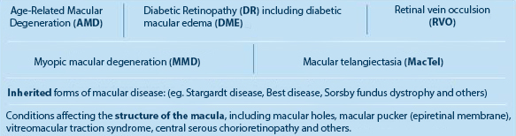
Source: MDFA
In many cases, macular disease cannot be prevented. However, early detection of macular disease is vital and enables people to access treatment and make lifestyle changes (such as changes to diet, smoking) to slow progression of the disease, slow vision loss or preserve sight for as long as possible.,
Age-related macular degeneration (AMD) is the most common macular disease in Australia. AMD primarily affects those over the age of 50 and the incidence increases with age. For people aged 50 and over, it is the leading cause of severe vision loss and blindness in Australia (causing 50 per cent of blindness). Treatment options are dependent on the stage and type of the disease and aim to stabilise and maintain best vision for as long as possible.
One in 7 people over the age of 50 years (approximately 1.29 million people) have some evidence AMD, and this is expected to increase to 1.7 million by 2030 in the absence of adequate treatment and prevention measures. Smoking is a key risk factor which increases the risk of developing AMD by 3-4 times, and developing AMD earlier (with smokers, on average, developing AMD 5-10 years earlier than non-smokers).,,
Everyone with diabetes is at risk of developing diabetic eye disease. Diabetic retinopathy (DR), including diabetic macular edema (DME) are complications of diabetes and the leading cause of blindness among working age Australians., In 2018 the estimated prevalence of diabetes in Australia was approximately 1.7 million people (1.2 million diagnosed and 500,000 undiagnosed type 2). Of the 1.2 million diagnosed with diabetes, approximately 300,000-400,000 (25-35%) have some degree of DR.,, Almost all people with type-1 diabetes and more than 60 per cent of those with Type 2 diabetes will develop some form of DR within 20 years of diagnosis. Significantly, many people with diabetes are diagnosed late, by which time retinopathy may already be present. Many cases of vision loss from DR can be prevented with regular eye examinations, careful management of diabetes, medication and in some cases, treatment with injections (anti-VEGF agents or steroids) and/or laser.
  - The impact of macular disease
Macular disease can have a profound impact on a person’s sight, and as such can impact on a person’s level of independence, ability to participate in economic and social activities, and their ability to undertake a range of activities of daily living (such as transport, shopping and household tasks).
Vision loss from macular disease can also impact on a person’s mental health, with social isolation, emotional distress and depression more common among people with the disease.
Macular disease can also increase a person’s reliance of informal supports (from family and friends), and on formal community-based services such as those funded through the aged care and disability support systems. Older people with macular disease and low vision or blindness are more likely to require residential care, and require care earlier in their lives, than people without any vision loss.
The total cost of vision loss associated with AMD specifically was estimated to be $5.15 billion in 2010. Financial Costs associated with treatment and management of AMD, which include drug-related as well as low vision aids-related costs, the cost of care, the deadweight efficiency losses from welfare/ taxation transfers, and a small component of productivity losses for people with AMD, were estimated to be $748.4 million in 2010.

- Macular disease and eye health services in Australia
Eye health programs and services, and specific macular disease programs and initiatives, are funded or provided by Commonwealth, State and Territory governments, non-government organisations, private sector providers and individual health care professionals.
In many instances, services, programs and initiatives for people with macular disease are part of broader eye health services and programs, although there are also a number of programs and initiatives that are specific to macular disease.
This section provides the strategic context for macular disease in Australia and describes the range of macular disease-specific programs and initiatives in place as well as broader eye health services and initiatives relevant for people with macular disease.
  - Strategic context and directions relevant to macular disease
In 2005, the National Framework for Action to Promote Eye Health and Prevent Avoidable Blindness and Vision Loss presented the challenges around the early detection of eye diseases, including macular disease, in an effort to prevent or reduce vision loss. Since then, a number of other National Frameworks or Strategies have been developed that focus on several chronic conditions which directly or indirectly impact on eye health, including:
- The National Strategic Framework for Chronic Conditions (2017), a policy document that provides guidance on strategies, actions and services to reduce the impact of chronic conditions in Australia.
- The Australian National Diabetes Strategy (2016-2020), a document that sets national goals and potential areas for action in the national response to diabetes, which specifically addresses diabetes-related eye disease (e.g. diabetic retinopathy).
- Internationally, the World Health Organisation’s Universal Eye Health Global Action Plan (2014-2019), which sets a target of a 25 per cent reduction in prevalence of avoidable visual impairment by 2019.
In addition, the National Eye Health Survey was conducted in 2016, and sought to determine the prevalence and causes of vision impairment and blindness in Australia and quantify the treatment coverage of eye health conditions across the country.
In May 2018, government funding was provided for the development of an Action Plan for macular disease to address the specific needs of the population affected by this disease.
  - Services for people with macular disease
People diagnosed with macular disease are likely to access health services to treat macular disease and manage symptoms, as well as support services and aids and technologies, particularly where the person has experienced some vision loss impacting their daily life.

3.2.1 Health Services
People with macular disease may access a range of primary health care services and specialist services available through State/Territory public health systems and the private health system.
For the majority of people diagnosed with macular disease, the disease is first detected through regular screening or examination by an optometrist including retinal photography, fluorescein angiogram and/or optical coherence tomography (OCT) scan.
Formal diagnosis of the condition is made by an ophthalmologist who can be accessed through referral by a general practitioner (GP) or optometrist to the public health systems or to private ophthalmology specialists.
Treatments for macular disease are again provided by ophthalmologists in the public or private health systems. Both public and private health services are able to access Medicare Benefits Schedule (MBS) subsidies relating to both ophthalmology consultations as well as specific eye treatment items. However, where people access services privately there is often substantial out-of-pocket costs.
Other specialist professions engaged in the delivery of eye care include orthoptists, ophthalmic nurses and optical dispensers.
The most commonly claimed eye treatment item for macular degeneration - intravitreal injection – accounts for the largest amount of Medicare benefits within ophthalmology, with approximately 400,000 injections (MBS item 42738) administered in 2017-18, costing $118 million in subsidy payments.
The most commonly used anti-VEGF agents that are listed on the Pharmaceutical Benefits Scheme (PBS) are Lucentis® (ranibizumab) and Eylea® (aflibercept) and are subsidised for the treatment of wet (neovascular) AMD, as well as DME and retinal vein occlusion (RVO). An alternative treatment, Avastin® (bevacizumab), is off-label and is not subsidised by the PBS – its cost ranges between $50 and $80 per dose.
Eye health workforce
According to the Australian Institute of Health and Welfare (AIHW), in 2015, there were around 4,560 optometrists registered in Australia (17.9 FTE per 100,000).
Figure 2- number and rate of optometrists by region 2015
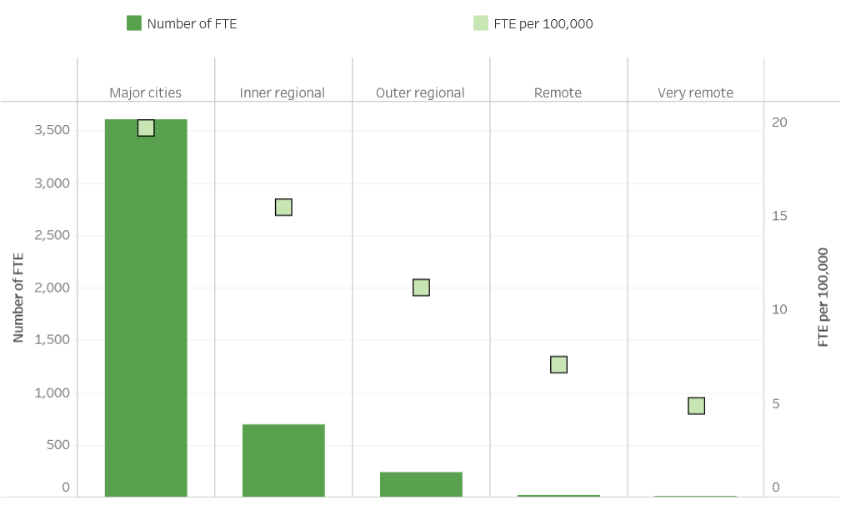
Source: AIHW
By jurisdiction the optometrist FTE rates per 100,000 per population range from 10.5 in Northern Territory to 19.5 in NSW.

Figure 3 - number and FTE rate of optometrists by jurisdiction 2015
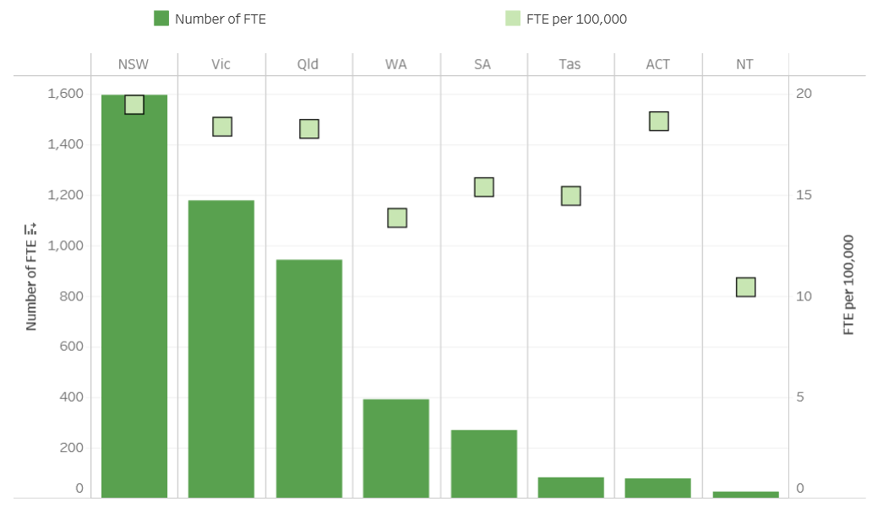
Source: AIHW
For ophthalmologists FTE rates per 100,000 population range from 3 FTE in Western Australia to 4.8 FTE in NSW.
Figure 4 - number and FTE rate of ophthalmologists by jurisdiction 2015
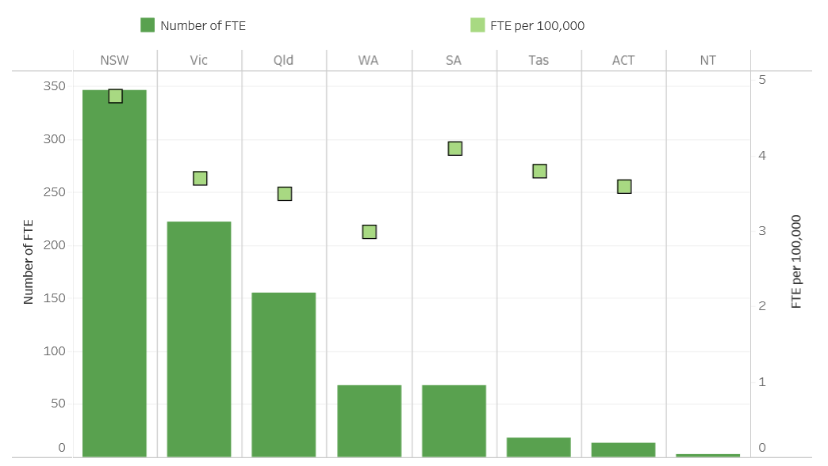
Source: AIHW

Over a four-year period from 2012-2015 there was an increase of ophthalmologists from 836 to 896.
Figure 5 - number and FTE rate of ophthalmologists 2012 to 2015
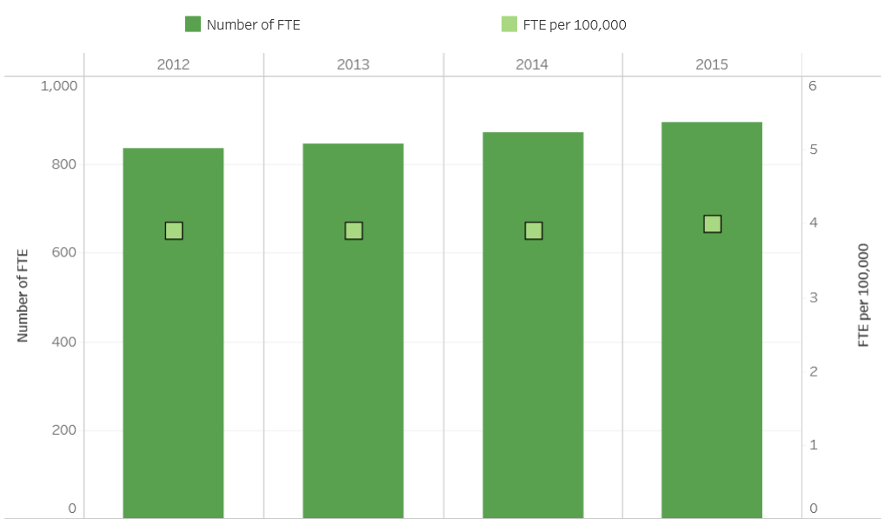
Source: AIHW
In addition to optometrists and ophthalmologists there are a range of allied ophthalmic personnel that provide support.
Figure 6 - number and rate of allied ophthalmic personnel by profession 2010
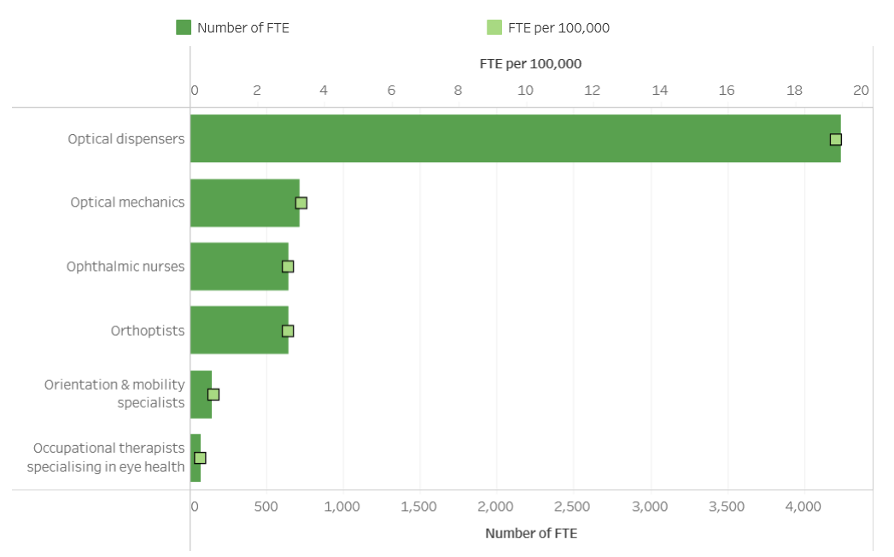
Source: AIHW
In addition to this specialist workforce, other health professionals such as GPs, nurses, pharmacists, Aboriginal health workers and the Royal Flying Doctor Service often provide basic services and advice relating to eye health. Others such as occupational therapists and physiotherapists may detect vision-related problems and recommend eye checks.

3.2.2 Support services
People with low vision or blindness caused by macular disease may also access a range of information, support services, and aids and technologies to assist them with activities of daily living (such as transport, shopping and household tasks) and to participate in social and community activities. Support services and technologies may be purchased privately or funded by governments through the aged care system or disability support system (National Disability Insurance Scheme - NDIS), or through State/Territory aids and equipment schemes.
Non-government organisations (NGOs) have a major role in providing information and support services. Organisations are typically funded by State/Territory and/or Commonwealth governments (for example through community aged care programs or the NDIS), although organisations may also have access to philanthropic funding and revenues raised through fundraising activities.
There are also a number of organisations focussed specifically on supporting people with low vision or blindness such as Guide Dogs Australia (which offers orientation, mobility and daily living supports and adaptive technology), Vision Australia (which offers training on the latest technologies and devices and guidance on living safely and independently) and the Fred Hollows Foundation.
Some NGOs also promote macular disease awareness, provide information and education for people affected by macular disease, and provide information for health professionals working with people with macular disease. People with macular disease can also access comprehensive information about macular disease and participate in support activities and events organised by Macular Disease Foundation Australia (MDFA).
- National initiatives and programs
Currently, there is a number of initiatives funded and provided at a national level that are relevant for people with macular disease. While there are a small number of macular disease-specific programs and initiatives, the majority relate to eye health more broadly and are accessed by, or provide benefit for, people with macular disease as well as a range of other eye health issues.
The majority of these initiatives are partly or fully funded by the Commonwealth Government and provided by a range of government and non-government organisations. It should be noted that all information has been sourced from publicly available documents, reports and websites, and in many cases specific data relating to funding or service provision was not available.
  - Macular disease-specific programs and initiatives
MDFA is nationally and internationally recognised as the Australian peak body for macular disease. Other than those provided by the MDFA, there are currently no other macular disease-specific programs or initiatives in place at a national level. The role of MDFA is to:
- Increase awareness of macular disease.
- Provide accurate, specific, current and ongoing information related to macular disease.
- Provide and facilitate access to relevant support and support services.
- Support and pursue research.
- Advocate for the best interests of the macular disease community.
Key national programs provided by MDFA are summarised in the table below.
Initiative | Description | Organisation | Action Plan Pillar
Macular disease public awareness campaigns and activities | MDFA run a series of national initiatives to help raise awareness of macular disease including:  - Macula Month – an annual campaign to encourage regular eye examinations and macula checks.  - myEYE World Competition - an annual photographic competition that emphasises the importance of vision (one off).  - ‘Meet Mac De Gen’ – Mac De Gen is a series of videos that present the facts around macular degeneration.  - National television and radio awareness campaigns for macular degeneration.  - Keep on Driving Safely – a national safety project drawing attention to the importance of good vision.  - World Sight Day – an annual day of awareness. | MDFA | Prevention + Early Detection
Education | MDFA’s education program provides information about all aspects of macular degeneration: symptoms, risk factors, treatment options, the importance of nutrition and lifestyle and living well with low vision. Programs include:  - Education for members of the public and community groups.  - Education for health care professionals. | MDFA | Prevention + Early Detection  Treatment  Support
Support services | MDFA provides support services to people affected with macular disease including:  - Helpline – provides an opportunity for in depth conversations about macular disease and its potential impact. They also refer to appropriate support services such as social services, accessing low vision aids and technologies and mental health services.  - Publications – a wide range of publications are produced to support an understanding of macular disease including risk factors, strategies for prevention, diagnosis, treatment and living with vision loss.  - Eating for Eye Health Cookbook – recipes focussed on ingredients that promote eye health.  - Newsletters – quarterly newsletters focus on issues relating to macular disease and the macular disease community.  - Low Vision Information Days – an education program for people with low vision, their families and carers to find out about, view and trial the latest low vision aids and technologies.  - Low Vision Advisory Service - free low vision advisory service, in conjunction with Guide Dogs NSW/ACT (Sydney). This free service involves an orthoptist working closely with the client to assess individual needs and determine which aids and technologies can help to best maintain independence and quality of life. | MDFA | Support
National Advocacy for Macular Disease Community | As the national peak body and lead voice for the macular disease community, MDFA plays a role in influencing and informing Australian health, aged care and disability policy agendas to drive improved outcomes for those living with or at risk of macular disease. Advocacy efforts ensure sight saving treatments for macular disease are accessible and affordable to all Australians. | MDFA | Prevention + Early Detection  Treatment  Support  Data + Research

  - Broader eye health and support programs and initiatives relevant for people with macular disease
Initiative | Description | Organisation | Action Plan Pillar
National Advocacy | Vision 2020 Australia organises and participates in national advocacy efforts for the Australian eye health and vision care sector, to raise public awareness. The organisation’s efforts follow key initiatives, including the Sustainable Development Goals, the National Framework Implementation Plan and the World Sight Day.  AMD is addressed indirectly, through the increased awareness around eye health. | Vision 2020 Australia | Prevention + Early Detection
Multilateral Trachoma Project Agreement | Trachoma, a bacterial eye infection, occurs mainly in remote and very remote Indigenous communities. Funding is provided to state and territory governments in WA, SA, NT and QLD to undertake trachoma screening and treatment activities, in line with the National Guidelines for the Public Management of Trachoma in Australia.  The Trachoma Project Agreement, although specific to trachoma, may raise awareness around eye health in general and promote screening and early treatment which may reduce the incidence of macular disease in remote and very remote Indigenous communities. | Australian Government, Department of Health | Prevention + Early Detection
Visiting Optometrists Scheme (VOS) | VOS supports optometrists to provide outreach optometry services in regional, remote and very remote locations that would not otherwise have ready access to primary eye care. The core VOS has been operating since 1975. Visiting optometry services form part of the broader primary health care program and frequently trains and mentors primary health care workers to identify and address the best opportunities for eye health checks and referral pathways.  The Scheme promotes awareness and facilitates the diagnosis of macular disease, among other eye diseases, across the regional, remote and very remote populations in Australia.  Figure 6 - VOS occasions of service, time trend, 2009-10 to 2016-17  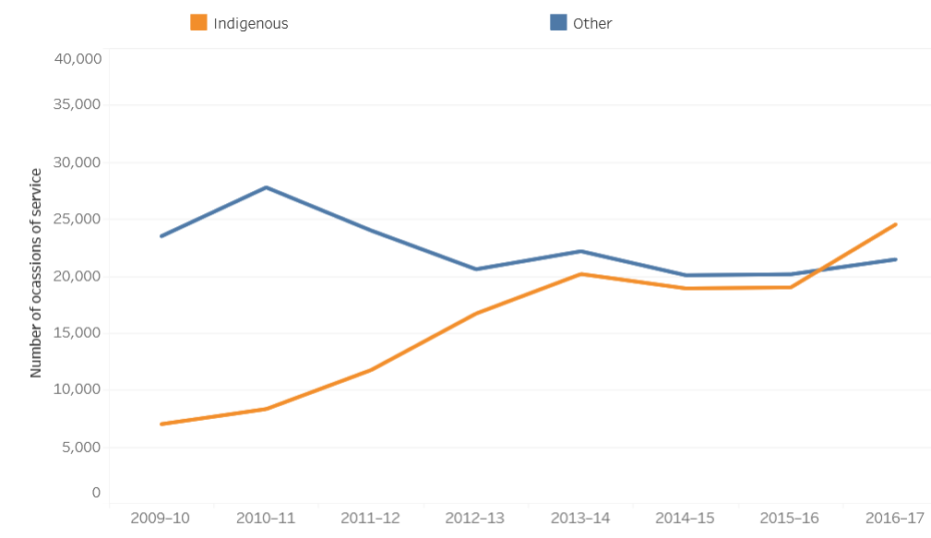  Source: AIHW | Australian Government, Department of Health | Prevention + Early Detection
Eye Surgical Support Program | The Eye Surgical Support Program expedites access to surgery for eye health conditions for Aboriginal and Torres Strait Islander patients who have been on lengthy waiting lists, with a focus on patients from rural and remote locations. This initiative supports travel and accommodation for the health professional, patient and carer. | Australian Government, Department of Health | Treatment
Medical Outreach Indigenous Chronic Disease Program (MOICDP) | MOICDP aims to improve access to medical specialists, GPs, allied and health professionals for all Aboriginal and Torres Strait Islander people experiencing health conditions under the MOICDP five health priorities: diabetes, cardiovascular disease, chronic respiratory disease, chronic renal (kidney) disease and cancer. Eye health needs associated with these chronic diseases (e.g. diabetic retinopathy) are supported through this program.  Figure 7 - MOICDP occasions of eye health services for Indigenous patients, time trend 2014-15 to 2016-17  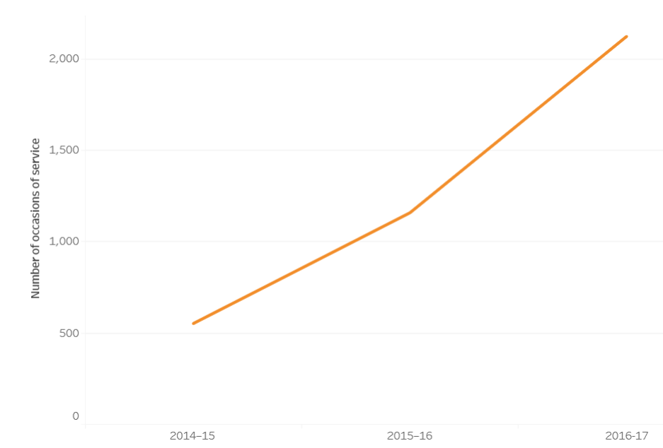  Source: AIHW | Australian Government, Department of Health | Prevention + Early Detection  Treatment
AMD information (Medibank) | Information provided on ultraviolet (UV) radiation and regular eye checks may improve people’s understanding and awareness of eye diseases (including AMD). | Medibank | Prevention + Early Detection
Do You See What I See? Initiative | The Do You See What I See? Initiative aims to increase understanding and awareness of eye health. It calls on those aged over 50 to have a regular eye examination, as the early detection of eye disease increases the chances of maintaining one’s vision, including those affected by AMD. | EyeQ Optometrists, Bayer Australia, MDFA | Prevention + Early Detection
Good Vision for Life | Good Vision for Life is a consumer campaign, designed to increase awareness of the role of optometrists and to motivate Australians to have regular eye examinations, with an aim for early detection of eye diseases, such as AMD and DR. | Optometry Australia | Prevention + Early Detection
Rural Optometry Group (ROG) | The ROG provides expert advice to the National Board of Optometry Australia on rural and regional matters with the aim of:  - ensuring the continued presence of a sustainable optometry workforce in rural and regional Australia which meets the needs of the community.  - enabling rural and remote optometrists to deliver the highest possible standard of care.  ROG’s work improves the coverage of eye health, including macular disease, in the rural setting. | Optometry Australia | Prevention + Early Detection  Treatment  Support
Rural Health Outreach Fund (RHOF) | The Rural Health Outreach Fund (RHOF) aims to improve access to medical specialists, GPs, allied and other health services in rural, regional and remote areas of Australia.  There are four priorities under the RHOF: chronic disease management, eye health, maternity and paediatric health and mental health. Services outside these priorities may also be supported. | Australian Government, Department of Health | Prevention + Early Detection  Treatment  Support
National Diabetes Services Scheme (NDSS) | The NDSS provides direct support to people with diabetes through access to subsidised products and services under the National Diabetes Services Scheme (NDSS). The NDSS also provides a range of educational and information services to assist with effective self-management of diabetes, including fact sheets on eye health.  Macular disease awareness is part of NDSS’s remit through the work they publish on eye health. | Australian Government, Department of Health + Diabetes Australia | Prevention + Early Detection  Treatment  Data and research
Guide Dogs Australia | Guide Dogs Australia represents Australia's six state-based Guide Dog organisations. Guide Dogs Australia member organisations provide a wide range of services that help people with vision loss to enhance their mobility and independence, and build their confidence for further education, employment and social participation. All services are provided at no cost to clients. | Guide Dogs Australia | Support
KeepSight Program | Developed in 2018, there are three key components to the program:  - The establishment of an eye examination alert and reminder system via the National Diabetes Services Scheme (NDSS).  - Creation and expansion of a digital eye health care provider platform with data linkages to the NDSS.  - Delivery of regular comprehensive eye examinations using existing networks of eye care and primary care providers. | Diabetes Australia + Vision 2020 Australia | Prevention + Early Detection

- State based initiatives
  - New South Wales
According to the 2016 Census, NSW had a population of 7.5 million, 2.9 per cent of which (216,176) were Aboriginal and/or Torres Strait Islander people.
In NSW, general eye health services are accessed at a local health district level, and there are currently eight Local Health Districts / Health Networks in NSW. Services in rural and remote areas are provided on a ‘fly-in fly-out’ basis, where an ophthalmologist visits local communities periodically.
In 2016, the State had 4.3 clinicians per 100,000 people.

Macular disease-specific programs and initiatives in NSW
There are a small number of macular disease-specific programs/initiatives in place in NSW.
Initiative | Description | Organisation | Action Plan Pillar
Macular disease advisory service and education | MDFA, in collaboration with other organisations, has organised macular disease-specific initiatives:  - Guide Dogs NSW/ACT, in collaboration with Macular Disease Foundation Australia, provides a low vision advisory service, which involves assessments and training conducted by a Low Vision Advisor. Guide Dogs' Orientation & Mobility specialists can then provide free follow up advice and training at the patient’s home.  - MDFA presents education sessions around Australia to members of the public, community groups and health care professionals. Education sessions can cover the topics of:  - AMD and research updates  - Living with low vision  The MDFA’s education sessions are free of charge and interpreters are made available for groups which have English as a second language. | MDFA  (+ NSW government for MDFA education sessions in NSW) | Prevention + Early Detection  Support
Carer Wellbeing Group | Carers NSW has formed a partnership with the University of Sydney, running a Carer Wellbeing group for those caring for a family member with AMD. The group is run on a fortnightly basis, over five weeks, through a telephone conversation facilitated by two trained counsellors. Carers are expected to develop coping strategies, learn about the benefits of mindfulness, discuss healthy communication styles and develop some self-care strategies. | Carers NSW | Support
EYECU Program | EYECU aims to prevent avoidable vision impairment and blindness by improving access to appropriate management for Sydney and Sydney Eye Hospital (SSEH) patients with ‘wet’ (neovascular) AMD. | NSW Health | Prevention + Early Detection

Broader eye health and support programs and initiatives relevant for people with macular disease
Broader eye health initiatives may not address macular disease directly, but they may indirectly have a positive impact for people with the disease. State-wide initiatives that address eye health across NSW include:
Initiative | Description | Organisation | Action Plan Pillar
State-wide Eyesight Pre-schooler Screening (StEPS) program | The StEPS program is an initiative of NSW Health and offers all 4 year old children free vision screening. NSW Health advises all children to have their vision screened before they start school and strongly recommends that all four year old children participate in the vision screening program. | NSW Health | Prevention + Early Detection
NSW Trachoma Screening Project | In 2014, NSW Health funds a state-wide trachoma screening project to include a further nine potentially at-risk communities in north western and far western NSW. | NSW Health | Prevention + Early Detection  Treatment
Ophthalmology Network | The Network is working to improve the experience and delivery of healthcare for people accessing public sector ophthalmology services in NSW, including cataract surgery, complex eye surgery and general ophthalmology consultations. | NSW Agency for Clinical Innovation | Treatment
Community Eye Care (C-EYE-C) Project | The Project aims to prevent avoidable vision loss and blindness through changes to the delivery of services to treat DR and glaucoma. | NSW Agency for Clinical Innovation | Prevention + Early Detection  Treatment
NSW Spectacles Program | The NSW Spectacles Program provides government-funded glasses, contact lenses and other vision aids to eligible applicants, through an online application and assessment process. | Vision Australia | Support  Treatment
Outreach Program | The NSW Rural Doctors Network is responsible for improving access to eye health care for Indigenous patients through the identification of barriers and gaps to access services and the implementation of new solutions. Several outreach schemes, organised by the Network focussed on funding specialist services including ophthalmology, optometry, eye care coordination and management of chronic diseases for Aboriginal and Torres Strait Islander people in NSW. | NSW Rural Doctors Network | Prevention + Early Detection  Treatment
Imaging, diagnostic services and eye health promotion | Centre for Eye Health (CFEH) offers free eye imaging and diagnostic services to the community and has seen around 38,000 patients, many of whom are characterised as high risk and are still being monitored. CFEH also promotes the visual health and well-being of the communities its services cover, by assisting eye-health practitioners in managing their patients, building on their clinical knowledge base and advancing visual assessment-related knowledge.  Centre for eye health is an initiative of the University of NSW and Guide Dogs NSW/ACT. CFEH is funded by Guide Dogs NSW/ACT. | Centre for Eye Health (CFEH) – funded by Guide Dogs NSW/ACT | Prevention + Early Detection
Low vision services | Vision Australia provides a number of services for people with vision loss and blindness. They provide low vision assessment, low vision aids and technologies, personalised solutions tailored to the needs of children, aged care services, access to audio library, employment assistance, braille training and other support services. | Vision Australia | Support
Low vision services | Guide Dogs NSW/ACT provides a number of services for people with vision loss and blindness. They provide Guide Dogs, low vision assessment and training, low vision aids and technologies, orientation and mobility training as well as training in daily living skills. | Guide Dogs NSW/ACT | Support

  - Victoria
Victoria has a population of 5.9 million, of which less than 1 per cent are of Aboriginal and/or Torres Strait Islander descent.
Victorian Clinical Networks work collaboratively to provide leadership and clinical service development across a number of healthcare areas, but do not directly cover eye health. Individual hospitals have more influence over the work and initiatives undertaken to promote eye health and address low vision and blindness.
The State had 3.6 ophthalmologists per 100,000 people in 2016.

Macular disease-specific programs and initiatives in Victoria
Initiative | Description | Organisation | Action Plan Pillar
Macular disease advisory service and education | MDFA presents education sessions around Australia to members of the public, community groups and health care professionals. Education sessions can cover the topics of:  - AMD and research updates  - Living with low vision  The MDFA’s education sessions are free of charge and interpreters are made available for groups which have English as a second language. | MDFA | Prevention + Early Detection  Support

Broader eye health and support programs and initiatives relevant for people with macular disease
Broader eye health initiatives may not directly address macular disease, but they may indirectly have a positive impact on the disease. State-wide initiatives that address eye health across Victoria include:
Initiative | Description | Organisation | Action Plan Pillar
Vision Initiative | The Vision Initiative is a multi-disciplinary effort involving a number of stakeholders including eye research centres and eye care services centres and focuses on five conditions: AMD, cataract, diabetic eye disease, glaucoma and under-/un-corrected refractive error. Managed by Vision 2020 Australia, the aim of the Vision Initiative is to prevent avoidable blindness and address the impact of vision loss in the Victorian community. The Vision Initiative works toward addressing all five key action areas of the Framework. The three strategic objectives of the Vision Initiative are to:  - increase the awareness and knowledge of at-risk, non-tested and under-tested groups about the importance of prevention activity, regular eye examinations and low vision services;  - improve the understanding and awareness of health professionals and eye health professionals about eye health and vision issues and referral pathways across the full continuum of care; and  - ensure a platform for collaboration and sustainable partnerships between Victorian eye health and vision care providers, government and other organisations. | Vision 2020 Australia | Prevention + Early Detection
Diabetes and eye health project | Vision 2020 Australia’s Diabetes and Eye Health project aims to increase rates of eye examinations in people with type 2 diabetes, and to improve the early detection and management of diabetic retinopathy – a condition that can lead to blindness in people with diabetes. | Vision 2020 Australia | Prevention + Early Detection
Koolin Balit Projects 2012–2022 | Koolin Balit is the Victorian Government's strategic direction for Aboriginal health over the next 10 years. The four eye health projects that form part of the strategy relate to the delivery, community engagement and health promotion of the Victorian Eyecare Service (VES) and the Victorian Aboriginal Spectacles Subsidy Scheme (VASSS) to raise community and sector awareness about eye health needs and options. | Victoria’s Aboriginal Health Strategy | Prevention + Early Detection  Research
Victorian Eyecare Service | The Victorian Eyecare Service (VES) provides optometry services at a low cost to Victorians who hold a pensioner concession card or health care card for a minimum of six months. The VES is funded through the Department of Health and Human Services and is run by the Victorian College of Optometry, through a network of optometrists and ophthalmologists. The primary care consultation fee is usually bulk-billed and patients pay a fixed amount towards the cost of glasses and contact lenses. | Victorian College of Optometry | Treatment
Low vision services | Vision Australia provides a number of services for people with vision loss and blindness. They provide low vision assessment, low vision aids and technologies, personalised solutions tailored to the needs of children, aged care services, access to audio library, employment assistance, braille training and other support services. | Vision Australia | Support
Low vision services | Guide Dogs Victoria provides a number of services for people with vision loss and blindness. They provide Guide Dogs, low vision assessment and training, low vision aids and technologies, orientation and mobility training as well as training in daily living skills. | Guide Dogs Victoria | Support

  - Queensland
Queensland is the second largest state in Australia, with more than half of its population of 4.7 million living outside the greater metropolitan area of Brisbane, making it less urbanised than other states. In 2016, 28.7 per cent (186,482) of Australia’s Aboriginal and Torres Strait Islander people lived in Queensland, with 54,158 of those living in Brisbane. According to Queensland Eye Institute (QEI), one in two Queenslanders have vision issues.
In 2016, the State placed below the national average in ophthalmologist representation, having 3.2 clinicians per 100,000 of population, which corresponds to 15 per cent of Australia’s ophthalmologists. Eye health services are decentralised and are provided by individual hospitals.

Macular disease-specific programs and initiatives in Queensland
Initiative | Description | Organisation | Action Plan Pillar
Macular disease advisory service and education | MDFA presents education sessions around Australia to members of the public, community groups and health care professionals. Education sessions can cover the topics of:  - AMD and research updates  - Living with low vision  The MDFA’s education sessions are free of charge and interpreters are made available for groups which have English as a second language. | MDFA | Prevention + Early Detection  Support

Broader eye health and support programs and initiatives relevant for people with macular disease
Broader eye health initiatives may not directly address macular disease, but they may indirectly have a positive impact on the disease. State-wide initiatives that address eye health across Queensland include:

Initiative | Description | Organisation | Action Plan Pillar
Indigenous Diabetes Eyes and Screening (IDEAS) Van | The Indigenous Diabetes, Eyes and Screening (IDEAS) Van, a custom made fully-equipped ophthalmology and optometry imaging specialist treatment centre, began providing its services in 2014, traveling through rural and remote Queensland and offering a “clinic on wheels”. This initiative was deemed an innovative “Close the Gap” project. The Van received Australian Government funding in 2018-19 and is currently providing access to specialist eye health services and treatment to indigenous clients to address service delivery gaps in regional, rural and remote areas of the State. | Diamond Jubilee Partnerships Ltd. | Prevention + Early Detection  Treatment
Surgery Connect | Surgery Connect is a Queensland Health initiative aimed at easing elective surgery waiting lists in public hospitals by treating selected patients in the private sector. The selection process is determined based on the amount of time each patient has waited for elective surgery – those who have waited longer than the recommended waiting time for their category and are on the waiting list may be offered the opportunity to be treated through the initiative. | Queensland Health | Treatment
Spectacle Supply Scheme (SSS) | The Queensland Government’s Spectacle Supply Scheme (SSS) provides a free pair of basic spectacles once every two years to holders of a concession card, health care card or Queensland Government Seniors Card.  Clients are generally responsible for all costs associated with the purchase of any extras, if they are required through personal choice rather than clinical need. Extras include tinting, photochromatic lenses, UV protection and hard coating. | Queensland Health | Treatment  Support
Low vision services | Vision Australia provides a number of services for people with vision loss and blindness. They provide low vision assessment, low vision aids and technologies, personalised solutions tailored to the needs of children, aged care services, access to audio library, employment assistance, braille training and other support services. | Vision Australia | Support
Low vision services | Guide Dogs Queensland provides a number of services for people with vision loss and blindness. They provide Guide Dogs, low vision assessment and training, low vision aids and technologies, orientation and mobility training as well as training in daily living skills. | Guide Dogs Queensland | Support

  - Western Australia
Western Australia’s population, according to the 2016 Census, was 2.5 million with Aboriginal and Torres Strait Islander people accounting for 3.1 per cent of the population. From a geographical point of view, WA is the largest state in Australia and has one of the highest life expectancies at birth in the country.
In 2016, the State had 2.7 ophthalmologists per 100,000 people, below the national average.

Macular disease-specific programs and initiatives in WA
Initiative | Description | Organisation | Action Plan Pillar
Macular disease advisory service and education | MDFA presents education sessions around Australia to members of the public, community groups and health care professionals. Education sessions can cover the topics of:  - AMD and research updates  - Living with low vision  The MDFA’s education sessions are free of charge and interpreters are made available for groups which have English as a second language. | MDFA | Prevention + Early Detection  Support

Broader eye health and support programs and initiatives relevant for people with macular disease
Broader eye health initiatives may not directly address macular disease, but they may indirectly have a positive impact on the disease. State-wide initiatives that address eye health across WA include:
Initiative | Description | Organisation | Action Plan Pillar
Health Promotion Strategic Framework (HPSF) | The WA HPSF sets out WA Health’s strategic directions and priorities for preventing chronic disease and injury over a five-year period (2017-2021), including eye health prevention. | WA Health | Prevention + Early Detection
Indigenous Tele-eye Care Trial | The Indigenous Tele-eye Care Trial is an initiative to demonstrate the use of satellite supported broadband network, to provide remote delivery of specialist eye care to Aboriginal and Torres Strait Islander Australians living in three rural and remote areas across Western Australia and Queensland. | Commonwealth Scientific and Industrial Research Organisation (CSIRO) + Indigenous and Remote Eye Health Service (IRIS) | Research  Treatment
Diabetic retinopathy (DR) Screening | Lions Outback Vision supported camera operators around the state to provide retinal screening for diabetic patients. | Lions Outback Vision | Prevention + Early Detection
Trachoma Control Program | The Trachoma Control Program aims to eliminate the potentially blinding bacterial eye infection trachoma in WA Aboriginal communities. | Western Australia Country Health Services | Prevention + Early Detection
Vision Van | The Lions Outback Vision Van is a mobile eye health clinic that showcases how collaboration, innovation and technology can be harnessed to deliver services in regional and remote areas to close the eye health gap. The Outback Vision Van incorporates a unique service delivery model that:  - Genuinely integrates collaboration across the health, corporate and community sectors;  - Is the first mobile clinic in WA to showcase the protocols and principals developed by the Aboriginal Health Council (WA) for outback service delivery in Indigenous communities;  - Performs integrative care, avoiding duplication by filling the gaps in existing hospital facilities and Aboriginal Medical Services sites around the State;  - Builds local capacity by up-skilling and training local health workers;  - Harnesses a strong partnership between community, corporate bodies and government to meet the increasing demand for eye health services. | Lions Outback Vision | Prevention + Early Detection  Treatment
Low vision services | Visibility/Guide Dogs WA is a local provider of disability services in WA for people with vision loss and blindness. They provide therapy services to help improve mobility and independence. They can visit people at their home to provide services, aids and equipment. They provide orientation and mobility services and social work support for those with vision loss or blindness, their family, carer or friends. They also provide a low vision assessment service for children and adults. They have a Guide Dog Program and can provide low vision aids and technologies. | VisAbility/Guide Dogs WA | Support
Low vision services | Vision Australia provides a number of services for people with vision loss and blindness. They provide low vision assessment, low vision aids and technologies, personalised solutions tailored to the needs of children, aged care services, access to audio library, employment assistance, braille training and other support services. | Vision Australia | Support

  - South Australia
Based on the 2016 Census, South Australia had a population of 1.7 million, with 2 per cent from an Aboriginal and Torres Strait Islander background. In 2016, the State had 3.9 ophthalmologists per 100,000 of population – above the national average.

Macular disease-specific programs and initiatives in SA
Initiative | Description | Organisation | Action Plan Pillar
Macular disease advisory service and education | MDFA presents education sessions around Australia to members of the public, community groups and health care professionals. Education sessions can cover the topics of:  - AMD and research updates  - Living with low vision  The MDFA’s education sessions are free of charge and interpreters are made available for groups which have English as a second language. | MDFA | Prevention + Early Detection  Support

Broader eye health and support programs and initiatives relevant for people with macular disease
Broader eye health initiatives may not directly address macular disease, but they may indirectly have a positive impact on the disease. State-wide initiatives that address eye health across SA include:
Initiative | Description | Organisation | Action Plan Pillar
Central and Northern Ophthalmology Network | The Central and Northern Ophthalmology Network runs an investigator initiated clinical trials unit at the Royal Adelaide Hospital and the Queen Elizabeth Hospital and has run a number of clinical trials. | Royal Adelaide Hospital and the Queen Elizabeth Hospital | Research  Treatment
Implementation of eye disease awareness campaigns for Aboriginal communities | Sight for All produced several videos which promote eye health, including:  - diabetic eye disease awareness video titled “Sid’s Bad Sugar”.  - cataract surgery awareness video titled “Big City Trip”.  - eye health awareness music video titled “Eyes”. | Sight for All | Prevention + Early Detection  Treatment
Low Vision Centre (LVC) | The LVC provides a specialist vision assessment to assist in determining the most appropriate support to assist patients to maintain their independence. In a friendly clinic setting a counsellor can have a chat about the challenges the patient faces, and an optometrist assesses their vision and prescribes suitable magnification aids that they can trial free of charge, prior to deciding whether to purchase them. Finally, an ophthalmologist (SA only) briefly examines the patient and answers any questions they may have about their eye condition.  A large range of daily living aids such as talking clocks, talking watches, liquid level finders and UV shields are also available for purchase. | Royal Society for the Blind | Prevention + Early Detection  Support
Eye health and Chronic Disease Specialist Support Program (EH&CDSSP) | The Eye Health and Chronic Disease Specialist Support Program (EH&CDSSP) coordinates and supports visiting eye specialists to most regional Aboriginal Community Controlled Health Services (ACCHSs), and among other activities, it is responsible for scheduling eye clinic dates, supporting and accompanying visiting eye specialists, transporting and managing specialised equipment and monitoring the patient referral pathway from primary to tertiary level eye health care. There are currently five optometrists and six ophthalmologists in the program. | Aboriginal Health Council of South Australia Inc. | Prevention + Early Detection  Support  Treatment
Same day elective and outpatient ophthalmology model of care | This project is reviewing the models of care for the following eye conditions:  - Cataracts  - AMD  - Glaucoma  - Diabetic retinopathy  - Paediatric eye diseases | System Redesign and Clinical Engagement,  SA Health | Prevention + Early Detection  Treatment
HealthPathways | HealthPathways is a web-based information portal to help primary care clinicians to plan patient care through primary, community and secondary health care.  Each pathway is an agreement between primary and specialist services on how patients with particular conditions will be managed in the local context.  This project is developing eye health pathways, including for macular disease. | System Redesign and Clinical Engagement  SA Health and Primary Health Networks | Prevention + Early Detection  Support  Treatment
Low vision services | Guide Dogs SA/NT provides a number of services for people with vision loss and blindness. They provide Guide Dogs, low vision assessment and training, low vision aids and technologies, orientation and mobility training as well as training in daily living skills. | Guide Dogs SA/NT | Support

  - Tasmania
Tasmania’s population was 509,965 in 2016, with 4.6 per cent of the population identifying as Aboriginal and Torres Strait Islanders.
Hobart is the only location in the State where treatment with anti-VEGF injections is available through the public health system. Those who live in the north of the State have to access private services. There are approximately four ophthalmologists in the public system who administer all the injections in Hobart.

Macular disease-specific programs and initiatives in Tasmania
Initiative | Description | Organisation | Action Plan Pillar
Macular disease advisory service and education | MDFA presents education sessions around Australia to members of the public, community groups and health care professionals. Education sessions can cover the topics of:  - AMD and research updates  - Living with low vision  The MDFA’s education sessions are free of charge and interpreters are made available for groups which have English as a second language. | MDFA | Prevention + Early Detection  Support

Broader eye health and support programs and initiatives relevant for people with macular disease
Broader eye health initiatives may not directly address macular disease, but they may indirectly have a positive impact on the disease. State-wide initiatives that address eye health across Tasmania include:
Initiative | Description | Organisation | Action Plan Pillar
Eye Stakeholder Forum | The first Tasmanian Aboriginal Eye Health Stakeholder Forum was held in Launceston on 7 June 2017. The aim of this event was to bring together key stakeholders involved in Aboriginal eye health in Tasmania to share experiences and discuss opportunities to improve current gaps and barriers to access. | TAZREACH | Prevention + Early Detection  Treatment
Lions Low Vision Clinic | The Lions Low Vision Clinic is a unit within the Royal Hobart Hospital Eye Clinic, specialising in helping people with poor vision make the best use of their remaining sight. | Royal Hobart Hospital Eye Clinic | Support
Spectacles Assistance Scheme | The Spectacles Assistance Scheme provides financial assistance for the purchase of spectacles to those people who meet the guidelines. | Tasmanian Health Service | Support
Low vision services | VisAbility/Guide Dogs Tasmania provides a number of services for people with vision loss and blindness. They provide Guide Dogs, low vision assessment and training, low vision aids and technologies, orientation and mobility training as well as training in daily living skills. | VisAbility/Guide Dogs Tasmania | Support

  - Australian Capital Territory
ACT Health provides publicly-funded health services to approximately 400,000 people in the ACT and an additional 200,000 people from the surrounding Southern NSW area.
Public eye health services are administered through the division of surgery and currently, (acute) services are provided through the Eye Clinic at Canberra Hospital, and community-based assessments are provided through community health centres and through Aboriginal health services.
Through a mixed public/private model, there are two retinal ophthalmology specialists, appointed to help meet the increasing demand for retinal services (related to new technologies with a focus on pharmaceutical treatments for diabetic retinopathy, macular degeneration and retinal vein occlusions). Other ophthalmologists focus on other conditions, such as cataracts and glaucoma. Treatment clinics operate three times per week and administer 40 injections each (20 per ophthalmologist), with an average of 2,500 appointments for retinal injections per year.
In 2016, there were 3.3 ophthalmology clinicians operating per 100,000 population in ACT, with a national average of 3.7 clinicians per 100,000 population.

Macular disease-specific programs and initiatives in the ACT
Initiative | Description | Organisation | Action Plan Pillar
Macular disease advisory service and education | MDFA presents education sessions around Australia to members of the public, community groups and health care professionals. Education sessions can cover the topics of:  - AMD and research updates  - Living with low vision  The MDFA’s education sessions are free of charge and interpreters are made available for groups which have English as a second language. | MDFA | Prevention + Early Detection  Support

Broader eye health and support programs and initiatives relevant for people with macular disease
Broader eye health initiatives may not directly address macular disease, but they may indirectly have a positive impact on the disease. Territory initiatives that address eye health across ACT include:
Initiative | Description | Organisation | Action Plan Pillar
ACT Health Diabetes Service | The ACT Health Diabetes Service and Endocrinology Service provide acute and ambulatory outpatient services to consumers of the ACT and surrounding NSW region, including Diabetes vision screening. | ACT Health | Prevention + Early Detection
Emergency Eye Clinic | The ACT Health Ophthalmology Unit offers assessments and treatment of non-critical eye injuries and provides a 24-hour on-call emergency service to Canberra Emergency Departments. | ACT Health | Prevention + Early Detection  Treatment
Aboriginal Health Service | The Winnunga Nimmityjah AHS provides an integrated client centric wrap around service (including eye health), which focuses on the clinical, cultural and spiritual needs of Aboriginal clients, families and the community. | Winnunga Nimmityjah Aboriginal Health Service | Prevention + Early Detection  Treatment
Low vision services | Vision Australia provides a number of services for people with vision loss and blindness. They provide low vision assessment, low vision aids and technologies, personalised solutions tailored to the needs of children, aged care services, access to audio library, employment assistance, braille training and other support services. | Vision Australia | Support
Low vision services | Guide Dogs NSW/ACT provides a number of services for people with vision loss and blindness. They provide Guide Dogs, low vision assessment and training, low vision aids and technologies, orientation and mobility training as well as training in daily living skills. | Guide Dogs NSW/ACT | Support

  - Northern Territory
The NT is the State with the lowest population density across Australia, with 0.16 people per kilometre and an overall population of 228,833. 25.5 per cent of the NT population are Aboriginal and Torres Strait Islander people.
In 2016, there were 1.9 ophthalmologists per 100,000 people in the NT, by far the lowest presence of clinicians across Australia and below the national average of 3.7.
In the NT, there is shared responsibility for the implementation of eye health services. The availability of public and private services is mostly limited to major hospitals, but there is a strong NGO presence such as the Fred Hollows Foundation and Brien Holden Vision Institute, which provide services in remote communities through local clinics.

Macular disease-specific programs and initiatives in the NT
Initiative | Description | Organisation | Action Plan Pillar
Macular disease advisory service and education | MDFA presents education sessions around Australia to members of the public, community groups and health care professionals. Education sessions can cover the topics of:  - AMD and research updates  - Living with low vision  The MDFA’s education sessions are free of charge and interpreters are made available for groups which have English as a second language. | MDFA | Prevention + Early Detection  Support

Broader eye health and support programs and initiatives relevant for people with macular disease
Broader eye health initiatives may not directly address macular disease, but they may indirectly have a positive impact on the disease. Territory initiatives that address eye health across NT include:
Initiative | Description | Organisation | Action Plan Pillar
Healthy Under 5 Kids Program-Partnering with Families | The program screens at 14 contact points of children aged 0-5 years for eye health and vision. Referrals to specialists are generated at the time of identification of issues. | Northern Territory Government | Prevention + Early Detection
Healthy School Aged Kids | Annual health checks of children aged 5-18 years are conducted in remote Indigenous communities using MBS item 715 Aboriginal and Torres Strait Islander Peoples Health Assessment, which incorporates trachoma screening. | Northern Territory Government | Prevention + Early Detection
Primary Health Care in Communities | Specialists from the ophthalmology outreach team can visit any community to check eye health. Community members are advised to go to their local health clinic, should they have eye problems. Should community members require further treatment, the specialists will send a referral to the hospital, which will assess that referral and arrange appropriate treatment. | NT Health | Prevention + Early Detection
Smart Eye Start | The Smart Eye Start initiative encourages all parents to take their children to have a full eye examination at an optometry practice prior to Prep or early on in schooling. | Optometry NT | Prevention + Early Detection
Integrated eye health | Over the past 10 years, the Fred Hollows Foundation and its partners have supported more than 700 patients like Maringka to receive surgery as part of the Central Australia and Barkly Integrated Eye Health Strategy (CABIEHS).  These surgeries have been conducted during 17 Eye Surgery Intensives led by  Dr Tim Henderson, the only ophthalmologist in the Central Australia region.  Dr Tim Henderson and his team service a population of more than 50,000 people, including 20,000 Aboriginal and Torres Strait Islander people, who are dispersed over an area larger than Spain (800,000 square kilometres). The next nearest services are in either Darwin or Adelaide. | The Fred Hollows Foundation/  Central Australia and Barkly Integrated Eye Health Strategy (CABIEHS) | Treatment
Aboriginal Vision Program | Since 2000, the Brien Holden Institute has provided education programs for Regional Eye Health Coordinators and Aboriginal Eye Health Workers. In 2007, after the identification of a need for regular and reliable optometry services in NT communities, the Aboriginal Vision Program was expanded to cover the state (previously it only covered NSW). The program includes a number of one-week workshops in both NSW and NT, funded by the Department of Health and Ageing Office of Aboriginal and Torres Strait Island Health and Department of Health and Ageing: Eye Health Demonstration Grant, NT Government Department of Health, and Rural Health Continuing Education Grants. | Brien Holden Vision Institute | Prevention + Early Detection  Treatment
Top End Eye Health Project | The purpose of the project is to improve the coordination of eye health and vision care services, and to develop a vision and broad parameters for a new model of service delivery for eye health and vision care services in the Top End of the NT. This is designed to meet local community needs in a complex environment which has geographic, workforce and patient challenges. | The Fred Hollows Foundation | Prevention + Early Detection  Treatment
Low vision services | Guide Dogs SA/NT provides a number of services for people with vision loss and blindness. They provide Guide Dogs, low vision assessment and training, low vision aids and technologies, orientation and mobility training as well as training in daily living skills. | Guide Dogs SA/NT | Support

- Macular disease research and data collection
Australia is home to major eye research organisations which focus on studying the impact of eye diseases and work towards preventing blindness through early diagnosis and developing better treatments for maintaining or restoring sight. Research activities in eye health, and macular disease in particular, may take the form of epidemiological studies, drug research and development projects, other novel therapy research, as well as socioeconomic studies.
The existence of eye health data is pivotal in informing research, for example, through registries of eye health patients, but also through the study of prevalence and incidence statistics of eye diseases and treatment patterns at the population level.
Very few research centres focus exclusively on macular disease. Various other research projects within larger eye health institutes are currently in progress and draw attention to eye health in general.
  - Macular disease and eye health research
Initiative | Description | Organisation | Action Plan Pillar
MDFA Research Grants Program | Since its launch in 2011, the MDFA Research Grants Program has committed almost $3.6 million to support world leading Australian researchers across 18 research projects. From 1 March 2019, a further $600,000 will be made available for the next grants round for research commencing in 2020.  The aim of the Research Grants Program is to fulfil the MDFA’s objective to support research to reduce the incidence and impact of macular degeneration and ultimately to find a cure for this chronic disease.  MDFA’s Grants and Fellowships make significant contributions to Australian medical, low vision and nutritional research into macular degeneration. They are awarded following rigorous evaluation, based largely on the National Health and Medical Research Council (NHMRC) process, along with international peer review, to ensure that the successful applicants meet the highest standards. | MDFA | Research
The Macular Research Unit | Centre for Eye Research Australia (CERA) is an independent medical research institute and the country’s leading eye research institute. The Macular Research Unit at CERA is working on a wide range of projects to improve diagnosis and treatment for AMD and to progress towards a cure. Professor Robyn Guymer AM leads the unit and is a recognised world leader in research and clinical management of AMD.  Some notable AMD projects include:  - A sub-study of the randomised controlled trial ‘Aspirin in Reducing Events in the Elderly’ (ASPREE).  - Applications for remote vision monitoring.  - Dark adaptation in early stages of AMD.  - Epidemiology of AMD.  - Laser intervention in early age-related macular degeneration (LEAD) trial.  - Structural and functional biomarkers for AMD. | CERA | Research
Drug Development | Opthea Limited, a Melbourne-based biotech company is working on the development of a new light-activated drug delivery for AMD. | Opthea Limited | Research
Various research projects | South Australia offers leading research and teaching initiatives on eye health, through the South Australian Institute of Ophthalmology. Key Research Projects of SAIO include:  - Novel photoreceptor bioenergetics: Basic science and clinical translation.  - Retinal ganglion cell bioenergetics with clinical translation.  - The genetics of periocular sebaceous gland carcinoma.  - Mitogen activated protein kinases in the optic nerve head in experimental glaucoma.  - Bioengineered tarsus tissue for eyelid reconstruction. | South Australian Institute of Ophthalmology (SAIO) | Research
Ground Breaking Research | The Ophthalmic Research Laboratory (ORL) undertakes ground breaking research on aspects of retinal cell biology and glaucoma. | Ophthalmic Research Laboratory | Research
Ophthalmology training program | The Royal Adelaide Hospital (RAH) and Queen Elizabeth Hospital are accredited by the Royal Australian New Zealand College of Ophthalmologists (RANZCO) for the ophthalmology training program. | Royal Adelaide Hospital (RAH) and Queen Elizabeth Hospital | Research
Various research projects | Queensland Eye Institute (QEI) is the only independent academic research institute dedicated to eye related health and disease in Queensland and currently treats more than 12,500 patients each year. It has provided more than 4,000 medical students and 60 registrars with advanced training. | The Queensland Eye Institute | Research
Centre for Health Research | The Centre for Health Research (Optometry) of the Queensland University of Technology conducts research in vision science and optometry. | Queensland University of Technology | Research
Various research projects | The Tasmanian Eye Institute has taken on a number of research projects, for example, ‘Uncover’, where the Institute was the highest global recruiting site for this global study looking at long term treatment regimens and effectiveness of ranibizumab for macular degeneration. | Tasmanian Eye Institute | Research
Research | The research team at CFEH works in collaboration with researchers and clinicians from a variety of other disciplines including optometry, ophthalmology, visual science and public health to use this resource to understand major eye diseases affecting Australians including glaucoma, AMD and DR. For example:  - Evaluating the utility of advanced imaging technologies in early detection and management of these eye diseases.  - Developing new clinical tests to improve early detection of these eye diseases. | Centre for Eye Health (CFEH) | Research
Indigenous Eye Health (IEH) | The IEH unit is funded to support a range of activities to improve the eye health of Aboriginal and Torres Strait Islander people. The unit aims to ‘Close the Gap for Vision’ for Aboriginal and Torres Strait Islander people through world-leading research, policy formation, advocacy and implementation. | Indigenous Eye Health Unit, Melbourne School of Population and Global Health, University of Melbourne | Research
Retinal and Eye Disease Research Group | The Centre for Vision Research studies eye diseases and the problems with the eye associated with other conditions such as obesity and coronary artery disease. | Centre for Vision Research, Westmead Institute of Medical Research | Research
Macular Research Group | Macular Research Group aims to develop new treatments that will reduce the prevalence of blindness from macular disease, through multidisciplinary, patient oriented, world class research. The group is made up of two cohesive research units and an innovative outcomes-based Fight Retinal Blindness! (FRB!) registry. | Save Sight Institute, University of Sydney | Research
Research Grants | Retina Australia is committed to raising funds for research into the detection, prevention, treatment and cure of inherited retinal dystrophies. Funds are distributed to scientific researchers in leading universities throughout Australia and New Zealand, and to the Inherited Retinal Diseases Register and DNA Bank in WA. | Retina Australia | Research
The Australian Inherited Retinal Disease Registry and DNA Bank (AIRDR) | The Disease Registry and DNA Bank is a research resource which collects DNA from consenting participants from all over Australia and genetically analyses this DNA in order to establish the cause of a participant’s IRD. | Sir Charles Gairdner Hospital | Research
Research Initiative (WA) | A Perth medical researcher, Professor Elizabeth Rakoczy, has won the Florey Medal for her work with dogs to help tackle macular degeneration. The gene therapy her team has developed involves only one injection, which could potentially be associated with a lower cost compared to the current treatment which involves several eye injections per year. | University of Western Australia/ Lion’s Eye Institute (LEI) | Research
Research Initiative (WA) | Dr Fred Chen’s research team at Lion’s Eye Institute (LEI) in Perth are testing new treatments in AMD and other retinal diseases and may in future be capable of restoring vision in patients with AMD. Dr Chen is affiliated with Royal Perth Hospital, a state-wide hub for adult ophthalmology. In 2018, LEI announced that it is creating a Centre of Research Excellence in Juvenile Macular Disease to spotlight an important cause of childhood blindness. | Lions Eye Institute (LEI) | Research
Knowledge Transfer | The ACT Health Ophthalmology Unit has linkages to RANZCO, which promotes research. | ACT Health Ophthalmology Unit | Research
Research Grants | The Ophthalmic Research Institute of Australia (ORIA) is a not for profit organisation dedicated to promoting research into the causes of eye disease and the prevention of blindness.  Research grants awarded each year have enabled many ophthalmologists and vision scientists working in university departments to improve the diagnosis and treatment of eye diseases through clinical research. | ORIA | Research

  - Macular disease and eye health data collection, monitoring and surveillance
Initiative | Description | Organisation | Action Plan Pillar
National Eye Health Survey | The National Eye Health Survey (NEHS) is the first and only national survey to determine the prevalence and major causes of vision impairment and blindness in Australia, prepared by CERA and Vision 2020 Australia.  Thirty geographic areas were selected using Australian Statistical Geography Standard data from the 2011 Australian Census and were grouped according to the Accessibility/Remoteness Index of Australia into five remoteness categories: Major City, Inner Regional, Outer Regional, Remote and Very Remote areas. A total of 4,836 eligible individuals were recruited and completed a general questionnaire to collect information about ethnicity, past eye health, stroke history and diabetes and underwent a series of eye tests, including: vision assessment, examination of the front of the eye, visual field testing, retinal photography and intraocular pressure test. | Vision 2020 Australia + CERA | Data
National Trachoma Surveillance and Reporting unit (NTRSU) | Australia is a signatory to the World Health Organization’s Alliance for Global Elimination of Trachoma by the year 2020 and is required to regularly provide data about trachoma prevalence. Funding is provided to operate the National Trachoma Surveillance and Reporting Unit (NTSRU), which was originally established to improve the quality and consistency of data collection and reporting of active trachoma in Australia. The NTSRU is currently operated by The Kirby Institute at the University of NSW. | Kirby Institute, University of NSW | Data
Indigenous Eye Health Measures | The Indigenous Eye Health Measures report is a national report on 22 Indigenous eye health measures. The measures cover the prevalence of eye health conditions diagnosis and treatment services for Indigenous Australians, the eye health workforce and outreach services. The report compiles data from a range of sources to provide a comprehensive picture of Indigenous eye health. | Australian Institute of Health and Welfare (AIHW) | Data
Registry of self-reported macular disease patients | MDFA maintains a database of all self-reported macular disease patients, all of whom receive newsletters and information from the Foundation. | MDFA | Data
There are a range of other, non-eye health specific data sources, including:
- Medicare data.
- Australian Institute of Health and Welfare data (Australia’s health, Disability services, Primary health care, Indigenous health & welfare services etc.).
- PBS data.
- Industry data e.g. pharmaceutical companies and equipment providers.
- NDIS.

References

Deloitte Access Economics and Macular Degeneration Foundation (2011). Eyes on the future: A clear outlook on Age-related Macular Degeneration. (2018 prevalence estimates are derived from a straight-line extrapolation between 2015 and 2020 estimates in this report).
NHMRC (2008). Guidelines for the management of diabetic retinopathy.
Keel S et al (2017). The prevalence of diabetic retinopathy in Australian adults with self-reported diabetes: The National Eye Health Survey. Ophthalmology. 2017;124:977-984
Dirani M ^{et al}. (2013). Out-of-sight- a report into diabetic eye disease in Australia. Baker IDI and Centre for Eye Research Australia (CERA).
Deloitte Access Economics. Bayer Australia. (2015). The economic impact of diabetic macular oedema in Australia.
Mitchell P et al (1996). Prevalence and Associations of Retinal Vein Occlusion in Australia. The Blue Mountains Eye Study. Arch Ophthalmol. 1996;114(10):1243-1247
Wong TY et al. (2014). Epidemiology and disease burden of pathologic myopia and myopic choroidal neovascularization: an evidence-based systematic review. Am J Ophthalmol. Jan;157(1):9-25.e12.
Issa PC et al. (2013). Macular telangiectasia type 2. Prog Retin Eye Res. May;34:49-77.
Parmeggiani F (2011). Clinics, Epidemiology and Genetics of Retinitis Pigmentosa. Curr Genomics. 2011;12(4):236-37.
Genead MA et al. (2009). The Natural History of Stargardt Disease with Specific Sequence Mutation in the ABCA4 Gene. Retina. 2009, Vol.50, 5867-5871
Dalvin LA et al. (2017). Vitelliform dystrophies: Prevalence in Olmsted County, Minnesota. United States. Ophthalmic Genetics. 2017 Mar-Apr;38(2):143-147.
Coussa RZ et al. (2017). Leber Congenital Amaurosis. A Compendium of Inherited Disorders and the Eye, Oxford University Press.
Forsythe E et al. (2013). Bardet-Biedel syndrome. Eur J Hum Genet. 2013 Jan; 21(1): 8–13.
Lentz J et al. (2016). Usher Syndrome Type I. GeneReviews: accessed at https://www.ncbi.nlm.nih.gov/books/NBK1265/
Deloitte Access Economics and Macular Degeneration Foundation. (2011). Eyes on the future: a clear outlook on age-related macular degeneration.
Dirani, M., Shaw, J. and Drowston, J. (2013). Out-of-sight- a report into diabetic eye disease in Australia. Baker IDI and Centre for Eye Research Australia (CERA).
Deloitte Access Economics and Macular Degeneration Foundation. (2011). Eyes on the future: a clear outlook on age-related macular degeneration.
Deloitte Access Economics and Macular Degeneration Foundation. (2011). Eyes on the future: a clear outlook on age-related macular degeneration. (2018 prevalence estimates are derived from straight line extrapolation between 2015 and 2030 estimates in this report).
Deloitte Access Economics and Macular Degeneration Foundation. (2011). Eyes on the future: a clear outlook on age-related macular degeneration.
Mitchell et al (2001). Five-year incidence of age-related maculopathy lesions: The Blue Mountains Eye Study. Ophthalmology 2001;109:1092-1097.
Tan J et al. (2007). Smoking and the long-term incidence of age-related macular degeneration: The Blue Mountains Eye Study. Arch Ophthalmol 2007;125:1089-1095.
Dirani, M., Shaw, J. and Drowston, J. (2013). Out-of-sight- a report into diabetic eye disease in Australia. Baker IDI and Centre for Eye Research Australia (CERA).
NHMRC (2008). Guidelines for the management of diabetic retinopathy.
Diabetes Australia. Diabetes in Australia. Accessed at: https://www.diabetesaustralia.com.au/diabetes-in-australia
Keel et al (2017). The prevalence of diabetic retinopathy in Australian adults with self-reported diabetes: The National Eye Health Survey. Ophthalmology. 2017;124:977-984
Dirani M, Shaw J, Drowston J. (2013). Out of Sight: a report into diabetic eye disease in Australia. Baker IDI and Centre for Eye Research Australia (CERA).
NHMRC (2008). Guidelines for the management of diabetic retinopathy.
Dirani, M., Shaw, J. and Drowston, J. (2013). Out-of-sight- a report into diabetic eye disease in Australia. Baker IDI and Centre for Eye Research Australia (CERA).
Macular Disease Foundation Australia. (2017). Low vision, quality of life and independence: a review of the evidence on aids and technologies. Macular Disease Foundation Australia, Sydney.
Macular Disease Foundation Australia. (2017). Low vision, quality of ^{life} and independence: a review of the evidence on aids and technologies. Macular Disease Foundation Australia, Sydney.
Wang, J. J., P. Mitchell, R. G. Cumming, W. Smith, and Blue Mountains Eye Study. (2003). Visual impairment and nursing home placement in older Australians: The Blue Mountains Eye Study. Ophthalmic Epidemiology 10(1):3–13.
Deloitte Access Economics and Macular Degeneration Foundation. (2011). Eyes on the future: a clear outlook on age-related macular degeneration. Canberra, Access Economics.
Deloitte Access Economics and Macular Degeneration Foundation. (2011). Eyes on the future: a clear outlook on age-related macular degeneration. Canberra, Access Economics.
Medicare Statistics, Australian Government Department of Human Services, http://www.health.gov.au/internet/main/publishing.nsf/Content/MC17-020105-MBS-co-claiming-restriction
MD Foundation, Eye Injection Costs and Rebates, https://www.mdfoundation.com.au/content/eye-injection-treatment-costs-and-rebates
There is no single comprehensive data source on the eye health workforce, and complete data is not available for all occupations.
Australian Institute of Health and Welfare. (2018). Indigenous eye health measures 2017 web report. Accessed at: https://www.aihw.gov.au/reports/indigenous-australians/indigenous-eye-health-measures-2017/contents/workforce-outreach-programs
Australian Institute of Health and Welfare. (2018). Indigenous eye health measures 2017 web report. Accessed at: https://www.aihw.gov.au/reports/indigenous-australians/indigenous-eye-health-measures-2017/contents/workforce-outreach-programs/4-4-1-occasions-of-service-vos
Australian Institute of Health and Welfare. (2018). Indigenous eye health measures 2017 web report. Accessed at: https://www.aihw.gov.au/reports/indigenous-australians/indigenous-eye-health-measures-2017/contents/workforce-outreach-programs/4-4-1-occasions-of-service-vos
Australian Bureau of Statistics, http://quickstats.censusdata.abs.gov.au/census_services/getproduct/census/2016/quickstat/5?opendocument
Agency for Clinical Innovation, https://www.aci.health.nsw.gov.au/resources/ophthalmology/eye-emergency-manual/eye-emergency-manual-resources/nsw-public-ophthalmology-clinics-information
Australian Government, Department of Health, Ophthalmology 2016 Factsheet, http://hwd.health.gov.au/webapi/customer/documents/factsheets/2016/Ophthalmology.pdf
Carers NSW. Carer wellbeing therapeutic group, https://www.carersnsw.org.au/Assets/Files/6.%20AMD%20Carer%20Wellbeing[2].pdf
Centre for Eye Health, http://www.businessannualawards.com.au/2017-Biography-Pages/Centre-for-Eye-Health
Australian Bureau of Statistics, http://quickstats.censusdata.abs.gov.au/census_services/getproduct/census/2016/quickstat/2?opendocument
Australian Government, Department of Health, Ophthalmology 2016 Factsheet, http://hwd.health.gov.au/webapi/customer/documents/factsheets/2016/Ophthalmology.pdf
Australian College of Optometry, http://www.aco.org.au/eye-care-services/eye-care-in-rural-victoria
Queensland Government, https://www.qld.gov.au/about/about-queensland/statistics-facts/facts
Australian Bureau of Statistics, http://www.abs.gov.au/ausstats/abs@.nsf/Lookup/by%20Subject/2071.0~2016~Main%20Features~Aboriginal%20and%20Torres%20Strait%20Islander%20Population%20Data%20Summary~10
Queensland Eye Institute, Retinal Eye Disease First for QEI, http://www.qei.org.au/page/home/latest-news/retinal-eye-disease-first-for-qei/
Australian Government, Department of Health, Ophthalmology 2016 Factsheet, http://hwd.health.gov.au/webapi/customer/documents/factsheets/2016/Ophthalmology.pdf
National Aboriginal Community Controlled Health Organisation (NACCHO), https://www.naccho.org.au/wp-content/uploads/2016_FINAL_NACCHO_Eye_Health_Report.pdf
https://www.iwc.org.au/single-post/2018/02/08/Vital-eye-specialist-service-for-Indigenous-people-with-diabetes-set-to-close
Australian Bureau of Statistics http://quickstats.censusdata.abs.gov.au/census_services/getproduct/census/2016/quickstat/5?opendocument
WA Health Clinical Services Framework 2014- 2024, Government of Western Australia https://ww2.health.wa.gov.au/~/media/Files/Corporate/Reports%20and%20publications/Clinical%20Services%20Framework/Clinical_Framework_2014-2024.pdf
Australian Government, Department of Health, Ophthalmology 2016 Factsheet, http://hwd.health.gov.au/webapi/customer/documents/factsheets/2016/Ophthalmology.pdf
Australian Bureau of Statistics, http://quickstats.censusdata.abs.gov.au/census_services/getproduct/census/2016/quickstat/4?opendocument
Australian Government, Department of Health, Ophthalmology 2016 Factsheet, http://hwd.health.gov.au/webapi/customer/documents/factsheets/2016/Ophthalmology.pdf
Australian Bureau of Statistics,
Consultation with Associate Professor Nitin Verma AM, ophthalmologist, Hobart Eye Surgeons and Associate Professor, University of Tasmania School of Medicine – see Summary of consultations for the development of a National Strategic Action Plan for Macular Disease, MDFA 2019.
ACT Health, Territory-wide Health Services Framework 2017-2017, http://health.act.gov.au/about-us/territory-wide-health-services/what-territory-wide-health-services-framework-2017-%E2%80%93-2027
Consultation with ACT Health – see Summary of consultations for the development of a National Strategic Action Plan for Macular Disease, MDFA 2019.
Australian Government, Department of Health, Ophthalmology 2016 Factsheet, http://hwd.health.gov.au/webapi/customer/documents/factsheets/2016/Ophthalmology.pdf
Australian Bureau of Statistics, http://quickstats.censusdata.abs.gov.au/census_services/getproduct/census/2016/quickstat/7?opendocument
Australian Government, Department of Health, Ophthalmology 2016 Factsheet, http://hwd.health.gov.au/webapi/customer/documents/factsheets/2016/Ophthalmology.pdf
Adelaide Medical School, https://health.adelaide.edu.au/medicine/disciplines/ophthalmology-and-visual-sciences
Queensland Eye Institute, http://www.qei.org.au/page/about/news/new-eye-centre-clear-vision-for-future/
Tasmanian Eye Institute, https://tasmanianeye.com.au/?page_id=41
http://www.abc.net.au/news/2017-12-06/florey-medal-winner-professor-rakoczy-speaks/9232318
Lion’s Eye Institute, https://www.lei.org.au/about/our-people/staff/dr-fred-k-chen/
Lions Eye Institute, https://www.lei.org.au/wp-content/uploads/2018/10/Centre-of-Research-Excellence-Juvenile-Macular-Disease.pdf
National Eye Health Survey Summary Report 2016 http://www.vision2020australia.org.au/uploads/resource/250/National-Eye-Health-Survey_Summary-Report_FINAL.pdf

